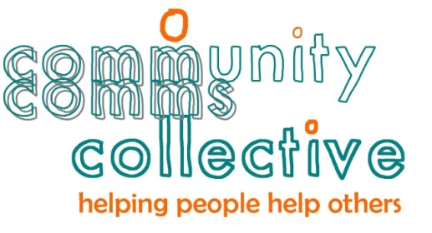
Communications plan template
Guide to this template
This template has suggested headings and comments to help you write a communications plan. Different projects or issues will require different levels of detail. This plan provides a starting point so feel free to tailor it to make it work for you.
Help us to help you
How helpful is this template? What parts were really useful, is anything missing, what areas would you like more guidance in? Email us on comms@communitycomms.org.nz. Thanks!

Purpose
- Provide one or two sentences about the topic your communications plan covers.
- Outline why you need to communicate.
Communication objectives
- List one or more objectives you want to achieve. These should be linked to wider project or organisational goals.
- It is useful to make your objectives SMART: specific, measureable, achievable/realistic and time bound.
Background and environmental factors
- It may be helpful if you insert a brief summary of the project or of previous communications on this topic, for example whether anything has been said to staff, stakeholders or the media.
- Write about any internal or external factors, for example:
  - related or interdependent projects, or
  - other external events that may impact on your communications (eg media coverage of a topical issue; another organisation’s activities that are relevant).

Stakeholders and audiences
- Ask yourself who needs to know, who can impact your work and who does your work impact? Then list them as either a stakeholder or audience:
  - stakeholders are those you want to work with in your communications or project
  - audiences are those you are wanting to communicate with.
- Do you need to break groups down? For example, the public may be too big a group and you might need to think about population sub-groups, like young people or those living in a particular suburb.
Approach
- Talk about (at a high level) how you plan to achieve your communications objectives – what approach will help you get there?
- Outline the rationale for your approach and the communication activity planned. For example, why you want to target a particular group and how your choice of channel (eg face to face meetings, or twitter) is suited to them.
- What are the barriers, risks and issues your communications needs to take account of?
Messages
- Your messages should be focused on your identified stakeholders and audiences. Use language they will understand and take into account their existing knowledge.
- Depending on the topic, you may develop different sets of messages for various audiences, tailored to their area of interest. Or sets of messages that change as time goes on.
- Focus on the end use/outcomes rather than the process.
- Can your messages highlight the positive difference your initiative will make to the audience or stakeholder groups?
- Use the what, when, why, who, where and how questions to make sure you’ve included the basic information in your messages.
- What is your call to action – what do you want people to do after they hear your messages?
Action plan
- When thinking about your communication activity think about tools and channels. A tool is something that contains your messages and the channel is how you get it across. For example:
  - tools – media releases, fact sheets, articles, brochures, question and answer sheets, posters, presentations, briefings, memos, a tweet or post
  - channels – news media, internet, twitter, facebook, conferences, workshops
- Who will do what? Who will be your spokesperson/people, who will draft the communications and who will approve it?
- You can structure your action plan as follows. You may not need all the columns.
Communications activity  (tool or channel) | Target audience | Who’s involved and what is their role | Timing | Resource (hours or dollars)

Measurement
- How will you know you’ve been successful, or whether you need to change your approach? Frequently used measures include:
  - formal research
  - debrief of project team
  - anecdotal feedback from customers (internal and external)
  - focus groups and surveys
  - number of website hits or retweets
  - Number of media clippings or coverage of key messages in the media

A quick check…
A good communication plan flows and its sections are connected. For example:
□ Do your objectives cover all your stakeholder and audience groups?
□ Is your approach in line with your objectives, and does your communication activity reflect your approach?
□ Do you have communication activity that targets each of your stakeholder and audience groups?
□ Are your messages appropriate for your different stakeholders and audiences?
□ Will your measurement technique help you assess how effectively you met your objectives?
To find out more, visit www.communitycomms.org.nz. For advice or a communications boost, email us at comms@communitycomms.org.nz

