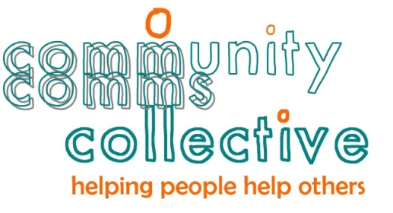
[EXAMPLE]
Website development plan for www.communitycomms.org.nz

PURPOSE

What is the purpose of the website?
- To enlist new volunteers and community organisations that need a comms boost, promote our services and workshops, and provide useful resources on comms-related topics.

KEY AUDIENCES

Who will visit the website?
- Communications people interested in volunteering.
- Community organisations that need a comms boost.
- Potential supporters.

KEY TASKS

Why do people come to the website? What are they coming to do?
Our key audience’s key tasks are:
- find out who we are and what we do
- sign up to volunteer
- request a volunteer
- request a website usability assessment
- find resources
- register for a workshop
- find contact details

DESIGN

How will the website ‘look and feel’?
We already have a logo developed and the site colours will reflect the logo colours.
On the Home page we’d like to show the human faces of our ‘collective’ by displaying a collage of photos of some of our volunteers.
We want the site design to have a clean and open feel with good use of ‘white space’.
We’ve commissioned some graphic icons that we will use to highlight key task information, add visual interest and tie in with the logo.
We’ve used highlight boxes on the home page to highlight key tasks.

NAVIGATION

How will the website be organised?
The main navigation sections and sub sections of the website, based on the key topics and tasks that our key audiences are interested in/wanting to complete, are listed below.
How we help
- Matchmaking
- Website usability assessments
- Case studies
Who we are
- People helping others
Volunteer with us
Resources
- Branding
- Change communications
- Email marketing
- Internal communications
- Media relations
- Privacy & personal data
- Profile raising
- Reputation management
- Social media
- Stakeholder relations
- Strategy and planning
- Visual storytelling
- Website usability
- Writing skills
What’s on
Volunteer with us

CONTENT

Who will develop and maintain the content?
[****] and [****] will rework the content from the current site and write any new content that is needed.
[****] will maintain the content using an online version of WordPress hosted by [****] with support from [****] and [****].

FUNCTIONALITY

What functionality does the website need?
The site will need one or more online forms to collect information from people interested in our services, wanting to volunteer, and/or wanting to register for our events.
Any functionality needed post launch can be requested and scoped with [****], prioritised and implemented if/when resources are available.

TECHNICAL ISSUES

What are the technical details and issues to be aware of?
Two site domains (URLs) are registered with [****] – communitycomms.org.nz and commscollective.org.nz.
The new site will be developed in WordPress and hosted by [****].
The site host will be responsible for keeping our version of WordPress up to date.
We will be responsible for installing the security plug ins and keeping them up to date.
Additional support can be requested from WordPress expert [****] and the site host.

RESOURCES

What resources are needed?
The site and content development work will be completed for free by volunteers – [****],[****] and [****].
The domain name and hosting fees are expected to be $[****] per year.
Where possible we will source images (and videos) for free from our own or our networks collections and free stock photo websites.

PROMOTION AND MEASUREMENT

How will the website be promoted? How will it’s effectiveness be measured?
We will promote the site and its content:
  - in social media posts
  - at events
  - in email signatures
  - on business cards
  - in awards applications.

We will analyse our Google analytics reports (including referrals from social media and search engines) to gain insights into how effective our website content is.

